Dr.LIYAQAT ALI (BHMS, PGDHHM, AIII)

Certified AI-Empowered SAFe® Product Owner/Product Manager/Lead BA

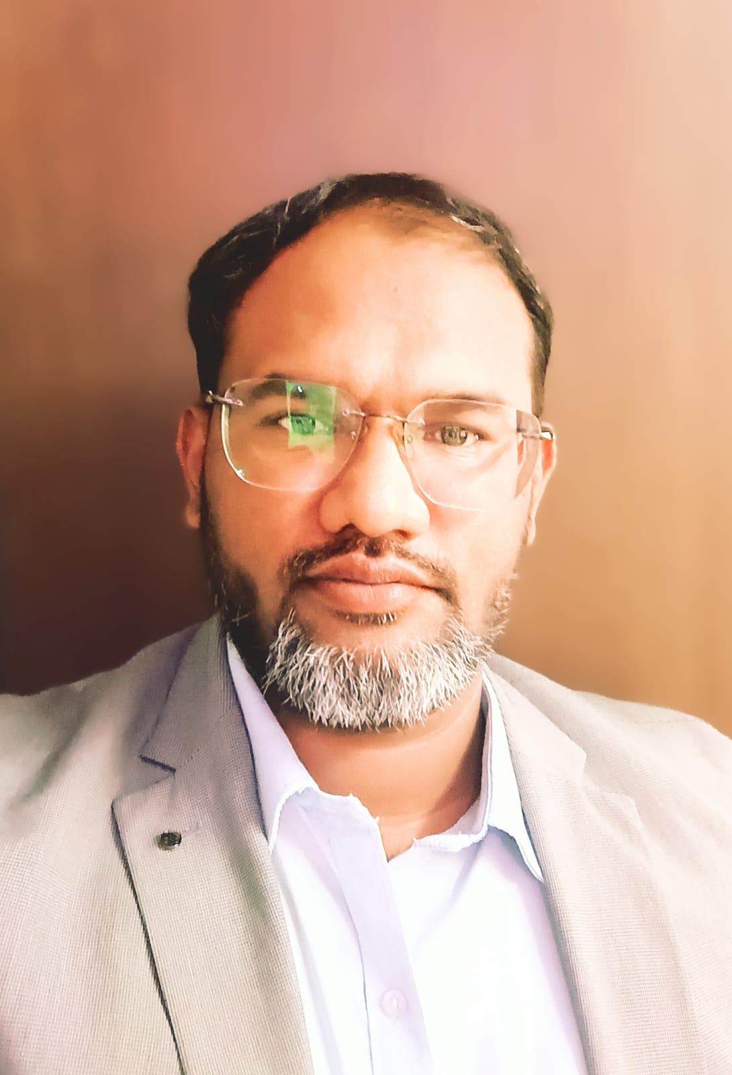
Current Location: Bangalore-India-560032
Email: Dr.liyaqatali@zohomail.in
Mobile: +91-8884880928
Passport: Indian Z6029817 (Valid till 01/11/2030)
Notice Period: Available for immediate joining
LinkedIn: www.linkedin.com/in/drliyaqatali9738709825

SUMMARY

- 15 years of professional expertise in insurance domain.
- 11 years of experience in product management, business requirements gathering, requirement elicitation, analyzing scope, gap analysis, designing solutions, prioritizing, managing backlogs, product roadmap, change request management, collaborations, demo’s and webinar’s.
- Worked in waterfall methodology for 4 year and SAFe agile since 6 year. Expert in agile ceremonies, backlog refinement, sprint planning, daily scrum, sprint review, sprint retrospectives.
- 15 years of expertise in managing teams, resolving conflicts, and managing escalations.
- Experienced and exposure to different geographies like US Insurance, Indian Insurance and APAC Insurance, and Saudi Arabia health Insurance.
- Expertise in Prompt Engineering techniques, Proficient in utilizing AI tools to enhance business processes and drive innovative solutions, delivering strategic insights and improving customer engagement. Passionate about integrating AI-driven technologies to optimize product development and achieve business objectives, BMAD, MCP (Model context protocol), RAG (Retrieval Augmented Generation).

SKILLS

- Business Analysis and Product owner: Requirements Elicitation, Gap Analysis, Process Modeling, EPIC, User Stories, Acceptance Criteria, Problem Solving, Critical Strategic Thinking, Backlog Management, Backlog refinement, Sprint planning, Sprint Review, Product Vision, Product road map, Risk Assessment, Change Management, Process Optimization, Solution Validation, Alternatives Analysis, Prioritization. PI planning.
- Modeling: BPMN (Business Process Model and Notation), UML Unified Modeling Language, Entity-Relationship Diagrams
- Methodologies: SAFe Agile, Scrum, Waterfall, Hybrid approaches
- Soft Skills: Stakeholder Management, Facilitation, Presentation, Negotiation, Project Management, Adaptability, Flexibility, Business Value, Product management.
- Documentation artifacts Skills: BRD, SRS, UC, RTM, User Stories, EPICs, Features, Product Backlogs, White Papers, Work flow diagrams, Wireframes, Sprint Goals.

Tools

Microsoft Office Suite | JIRA | Confluence | Bugzilla
MS Visio | Power Point | Smart Draw | BQRM
FileZilla | WinSCP | SoapUI | MIRO
Claude code | ChatGPT | Prodigy

EMPLOYMENT DETAILS

Chubb Business Services India Pvt Ltd, Bangalore (11/2024)-(06/2026)
Role: Lead Business Analyst
- Led SDLC and PI planning activities as PO, translating complex business requirements into Epics, User Stories, and Acceptance Criteria in JIRA/Confluence, partnering closely with Business Users and engineering teams across multiple SAFe agile pods.
- Leveraged AI prompt engineering, Gen AI to document PRD’s, optimizing requirements analysis, decision workflows, creating HTML Screens and pages, Leveraging BMAD setups, MCPs (Model context protocol), RAG (Retrieval Augmented Generation), creating Skills and agents for day today BA and PO tasks.
- Key Projects Delivered & Managed
- Drove delivery of Digital FNOL platforms (MYACCOUNT, CSP 3.0 APAC Region) with integrations across Policy Admin, DCP, Claims Connect, and MDM systems, supporting Travel Insurance, A&H, Cyber Security, and Home and appliances insurance products.
- Drove Delivery of Singapore Travel products STP, STR, STD rules (CDF-Claim Decision framework) to automate claim processing.

Mphasis Ltd, Bangalore (04/2020)-(11/2024)
Role: Senior Business Analyst
- Actively involved in PI planning as PO across the SDLC, analysing business needs and translating them into clear, actionable system requirements. Conducted interviews, surveys, workshops, and observations to gather requirements, identify gaps, and define project scope and objectives.
- Designed and implemented system solutions by collaborating closely with consultants, product committees, Engineering teams, and business users, ensuring solutions were feasible, functional, scalable, and user-friendly.
- Evaluated and improved system performance and quality through Functional testing, validation, and verification, ensuring alignment with specifications, standards, and business expectations.
- Led team of BA’s: Mentored and trained BA’s on best practices and tools, and conducting quality reviews to ensure consistency and accuracy of deliverables.
- Collaborated with cross-functional stakeholders throughout the SDLC, building strong relationships with business users, developers, testers, managers, vendors, and external partners.
- Acted as a liaison and facilitator to ensure alignment and consensus on system requirements, design decisions, and implementation strategies.
- Successfully managed and delivered two concurrent projects, balancing priorities, timelines, and stakeholder expectations.
- Key Projects Delivered & Managed
  - Javelina Claim Processing Platform : modules such as Plan Building, Adjudication Logic, Claim Pricing, Editing, Auditing, and Processing, Network Maintenance, JQS, System Configuration, Claim Batching, EDI 837,835, Authorizations.
  - Project Managed: Member Mobile App & Portal : Features such as Claim Status, ID Cards, Provider Search, Price Comparison, Coverage & Eligibility, Resources & Notifications, User Profile Management.

iNube Software Solutions ltd, Bangalore (08/2015)–(03/2020)
Role: Senior Business Analyst
- Led end-to-end software development lifecycle (SDLC), including business requirements analysis, stakeholder interviews, surveys, scope definition, and solution design aligned with business objectives.
- Acted as a strategic liaison between business stakeholders, consultants, and development teams to deliver user-centric, scalable system solutions.
- Facilitated stakeholder alignment across multiple business units, maintaining strong relationships and ensuring timely decision-making and delivery.
- Authored and maintained BRDs, FRDs, user stories, process flows, and UAT scenarios; supported testing and post-implementation reviews.
- Drove process optimization and automation initiatives, improving operational efficiency and end-user experience across insurance platforms.
- Key Projects Delivered & Managed
  - Oracle Health & Portal – Al-rajhi Takaful Health Insurance (Riyadh, Saudi Arabia | Onsite):Led requirements gathering and system implementation for Oracle Health and customer portals, supporting enterprise-scale health insurance operations.
  - Claims Live – Health Insurance Claims (Religare Health Insurance Co. Ltd):Delivered an end-to-end health claims management platform covering intake, adjudication, settlement, and reporting.
  - Claims Live – Motor Insurance Claims (Universal Sompo General Insurance Co. Ltd): Implemented a motor claims processing system streamlining claim lifecycle management and reducing manual intervention.
  - Home Appliances Extended Warranty Platform (Bharti Assist Global Services Ltd): Designed a micro-insurance platform for extended warranty certificate issuance and policy management for consumer appliances.
  - SMOOTHIE – Flight Delay Insurance Policy & Claims System: Developed a digital insurance solution for automated policy issuance and flight delay claims processing.
  - Partner Portal – Reliance Health Insurance Co. Ltd: Delivered a partner sales journey platform enabling multi-channel health insurance distribution and partner on boarding.

Medicare TPA Services (I) Pvt ltd, Bangalore (04/2013)–(07/2015)
Role: Senior Manager

- Delegated Day to day branch Operations, Team Management, Team Building, New business development, Managing existing business and clients, Sales and services, managed 4 different teams such as,
- RSBY Project: this project was for Enrollment, Claims Processing and F&I management team.
- Provider Network: Led team for Empanelment of hospital diagnostic centers, Rate negotiation with vendors and obtaining discounts on rates.
- Fraud & Investigation: Oversaw Investigation team to ascertain the genuineness of cashless and reimbursement claims.
- CRM: Facilitated customer centric operations. Customer satisfaction by delivering quality services on time.

Dedicated Health Care Services TPA India Pvt ltd, Bangalore (06/2011)– (03/2013)
Role: Branch Manager

- Delegated daily branch operations, including team management, team building, and business development.
- Effectively handled existing clients and handled sales and services.
- Supervised and trained3 teams. Claims processing team, Provider network team in hospital empanelment, rate negotiations, and payment coordination. Fraud & Investigation team to verify claim authenticity and address fraudulent activities.

EDUCATION

Post Graduation: PGDHHM, Year (2011-2012), Symbiosis, Pune
Graduation: BHMS, Year (2004-2010), GHMC, Bengaluru

CERTIFICATION

ASSOCIATE, (03/2020), III, Mumbai

LICENTIATE, (09/2015),III, Mumbai

Certified AI-Empowered SAFe® Product Owner/Product Manager, (06/2026-06/2027)

LANGUAGES
English, Urdu, Kannada, and Hindi

AWARDS & RECOGNITIONS
- Rising Star, Year (2025) at Chubb
- Zenith Award, Year (2022) at Mphasis
- Process Innovation, Year (2018) at iNube

